**Used:**

* Spring Boot
* Thymeleaf – a template engine(for view)
* Mysql database

Created database ‘Spring’ in Mysql.

*Created table ‘Hotel’. It has following data:*

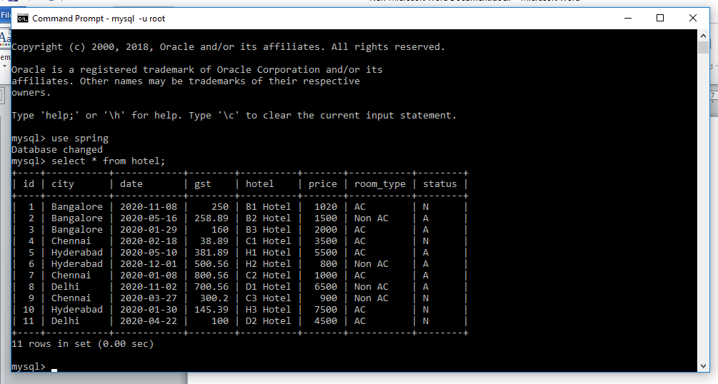

**Execution screenshots:**

Homepage: <http://localhost:8080/index>

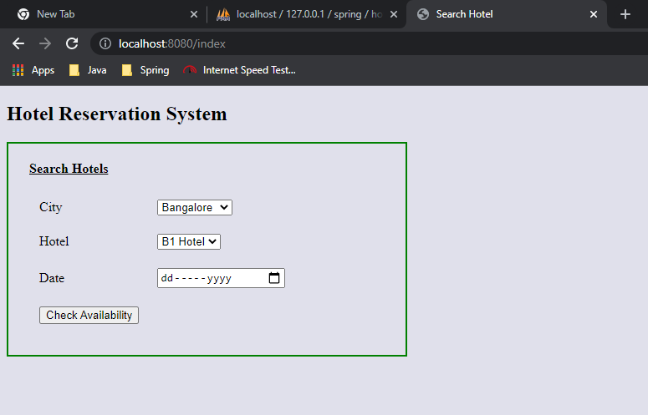

Data is populated into City,Hotel dropdown from the Hotel table in mysql DB.

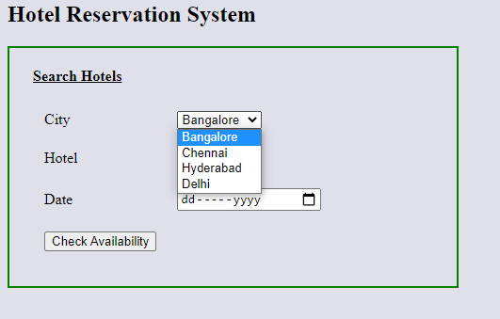

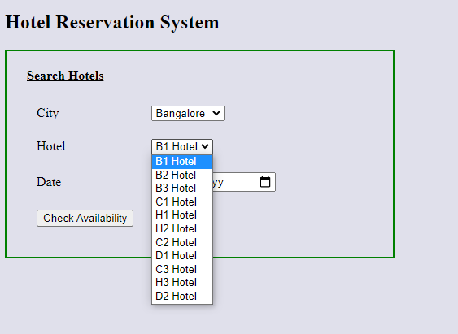

Case 1: If the hotel is not available for the mentioned date:

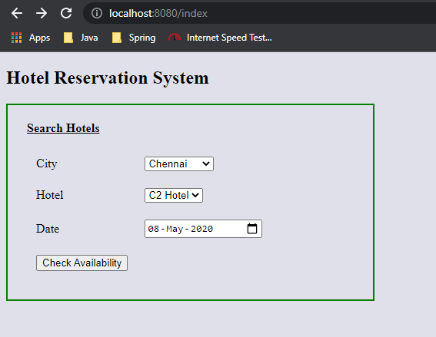

On clicking on ‘Check Availability’, page is displaying appropriate message informing about the unavailability for the date chosen:

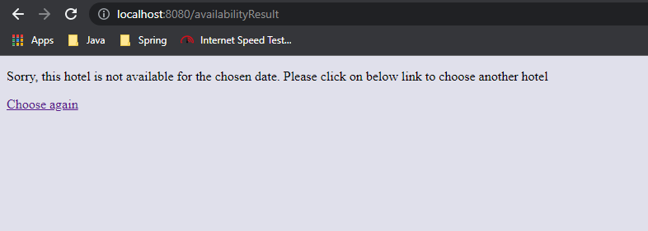

Click on ‘Choose again’ to select other date:

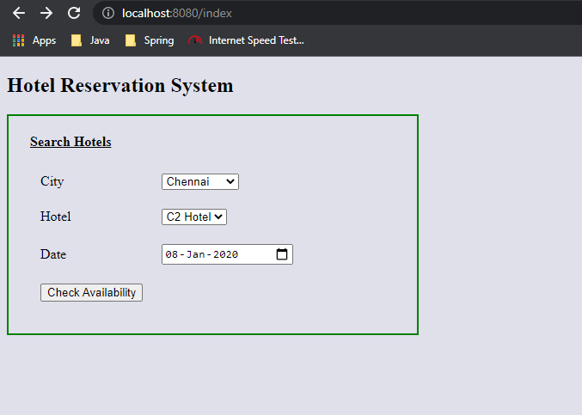

Case 2: Making proper hotel selection (one that is available in the city) with status available.

On clicking ‘Check Availability’, it redirects to page below:

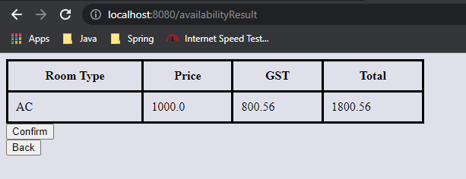

Click on ‘Confirm’ to book. After that fill out the form:

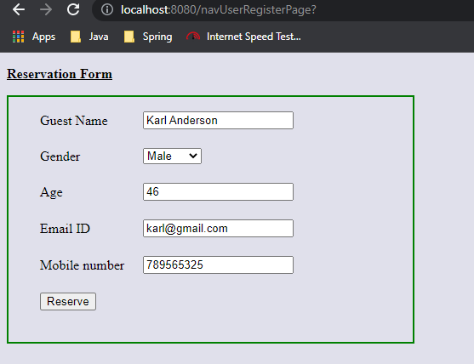

Click on ‘Reserve’. Then it displays booking confirmation:

